
Acadia Talks- The American Election
What is shaping up to become a historic election is unfolding just south of our border, and the outcome could mean big changes for the US as well as for us Canadians. But who are the candidates running and what changes are they proposing? Who do you think is the best choice?

Democratic Party Candidates
Hillary Clinton – Former Secretary of State
- Build on Obamacare, equal pay for women, require outside groups to publicly disclose significant political spending, close corporate loopholes and raise taxes on the wealthiest, generate enough renewable energy to power every home in America within 10 years, have 500 million solar panels installed across the country by 2020, invest $350 billion to ensure no student has to borrow to pay for tuition, books, or fees to attend a four-year public college in their state, enable Americans with existing student loan debt to refinance at current rates
- Clinton has received donations of all sizes.
Bernie Sanders – Vermont Senator, Self-described Democratic Socialist
- Switch the US to Universal Health Care, Raise the minimum wage from $7.25 to $15/hour, make public colleges and universities tuition-free, break up the 6 largest financial institutions to avoid another economic crash, allocate $1 trillion to create a Federal Jobs Program that will aim to repair crumbling infrastructure and employ 13 million Americans, avoid getting involved in other war/foreign policy blunder like the Iraq War, transition the energy sector from fossil fuels to 80% renewable energy by 2050, expand social security, opposing trade deals like the TPP, public funding of elections, address racial injustice and end the Federal prohibition on marijuana
- Sanders is funding his campaign through public funding. He has received over 3 million donations averaging $27.

Republican Party Candidates (*Only those polling above 10%)
Donald Trump – Businessman, TV personality
- Temporary ban on Muslims entering the US, build a wall between the US and Mexico, return “all criminal aliens” to their home countries (estimated 5 million of people), 15% business flat tax, no income tax below $25,000/year, avid defender of second amendment rights (guns), lower the corporate tax rate, cut the head off ISIS and blow up their oil fields.
- Trump is self-funding his campaign
Ted Cruz – Junior Texas Senator, Tea Party Member
- Defend religious liberty, “bomb the shit out of ISIS,” believes in traditional marriage (between one man and one woman), investigate planned parenthood, immediately repeal Obama’s Iran Nuclear Deal, collapse personal income tax into a single low rate of 10%, expand fossil fuel production, shrink government by eliminating the IRS, Department of Education, the Department of Energy, the Department of Commerce, and the Department of Housing and Urban Development
Marco Rubio – Florida Senator
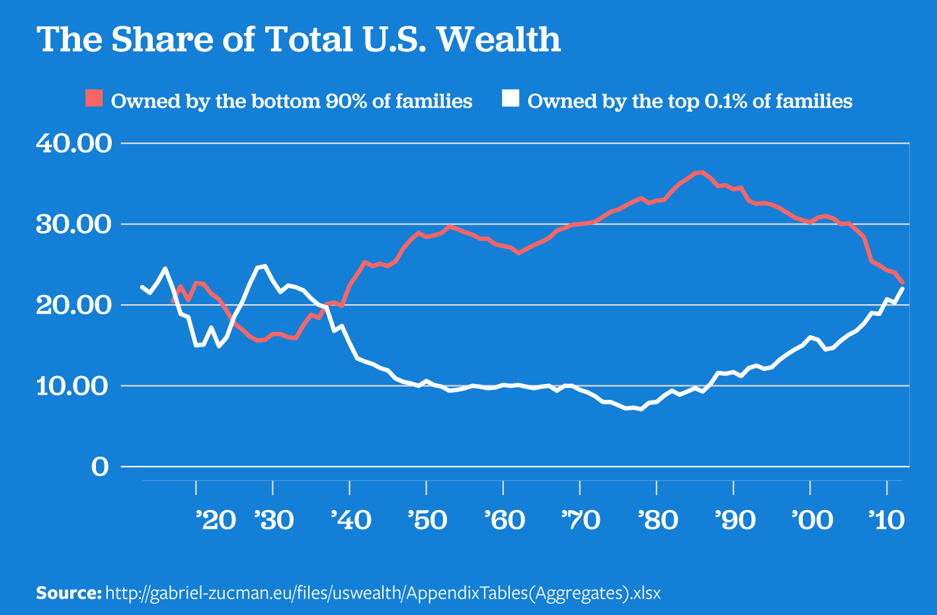
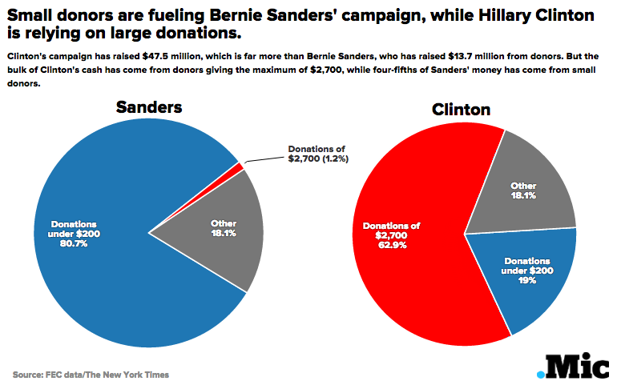
- Stop the federal government from pushing Common Core on states and give states and localities control over education, Repeal Obamacare, stop taxpayer funding of abortions, Immediately Approve the Keystone XL Pipeline, cut taxes for business of all sizes, 15% income tax for individuals up to $75,000/year, 25% for up to $150,000, and 35% for over $150,000.
Do you enjoy discussing world events? Then join Acadia Talks!!
We are a club that meets every 2 weeks on Tuesday evenings to have an open, round-table discussion about important global issues.
When/where? 6-8pm in the KCIC seminar room (More details posted on Facebook before each talk) https://www.facebook.com/AcadiaTalks
Add us on Facebook or contact Luke at 113844e@acadiau.ca for info.
ALSO listen to Axe Radio on Fridays from 6-7pm to hear further discussion on these issues. http://axeradio.ca/listen-live/

