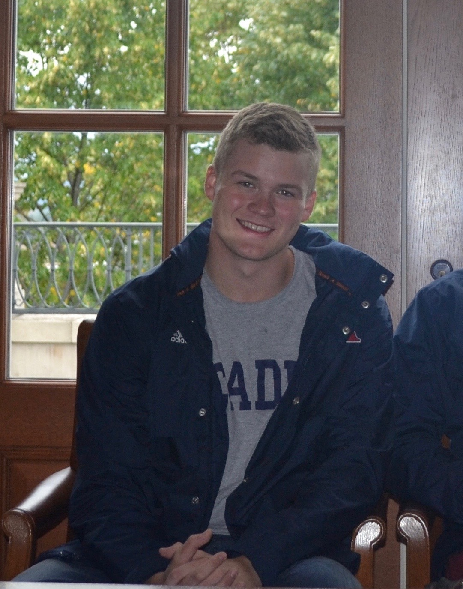
Hello my fellow Acadia peers! My name is Calum McCracken and I am a fourth year political science student, with a minor in legal studies. Moreover, I am running for the vacant Student Councillor position alongside my colleague, and fellow political science student Carter Bobbie! I am committed to fulfilling the duties of said office, and will strive to represent the entirety of the student body. Further, I will remain receptive and considerate to the diverse pallet of issues and interests that populate our Acadia community. As a political science student whom studies contemporary, cultural, and administrative issues on an intellectual level, I believe I can offer a unique input on matters pertaining to the sociopolitical makeup of the Acadia community. Over my three-year career at Acadia University I have gained insight both inside and outside the classroom, and hope to be given an opportunity to let my actions reflect this, if given the opportunity to hold the office of Student Councillor.

